学号：201908130301 姓名： 孟鸿芸

本章学习总结：

css的优势：

1. 内容和表现分离
2. 网页结构表现统一，可以实现复用
3. 样式丰富
4. 建议使用独立于html的css文件
5. 利于SEO，容易被搜索引擎收录！

文本样式

颜色 color rgb rgba

文本对齐方式 text-align = center

首行缩进 text-indent: 2em

行高 line-height: 单行文字上下居中！ line-height = height

装饰 text-decoration:

文本与图片水平对齐 vertical-align: middle

 表单增强：   1、日期，时间、搜索 （input）

 2、表单验证（html4 js    通过min,max,pattern来验证）

3、Placeholder 自动聚焦 （autofocus）

html5新增语义

1、header/footer 头尾（网站头部，区块头部）

2、section/article  (区域) 相对于div，div是没有语义的，section零碎，article更完整

3、nav  导航

4、aside 不重要的内容（侧边栏），广告

5、em/strong 强调  强调、粗，相对于i，b  他们更有语义化

6、i icon    i保留，用来做图标，为icon

html5 增加最多的是api（包括本地缓存，视频之类）

12、html元素分类

 1、按照默认样式分类、

 1、块级block

 2、行内inline

 3、行内块inline-block

作业自评分：100

页面运行效果截图：

页面一：

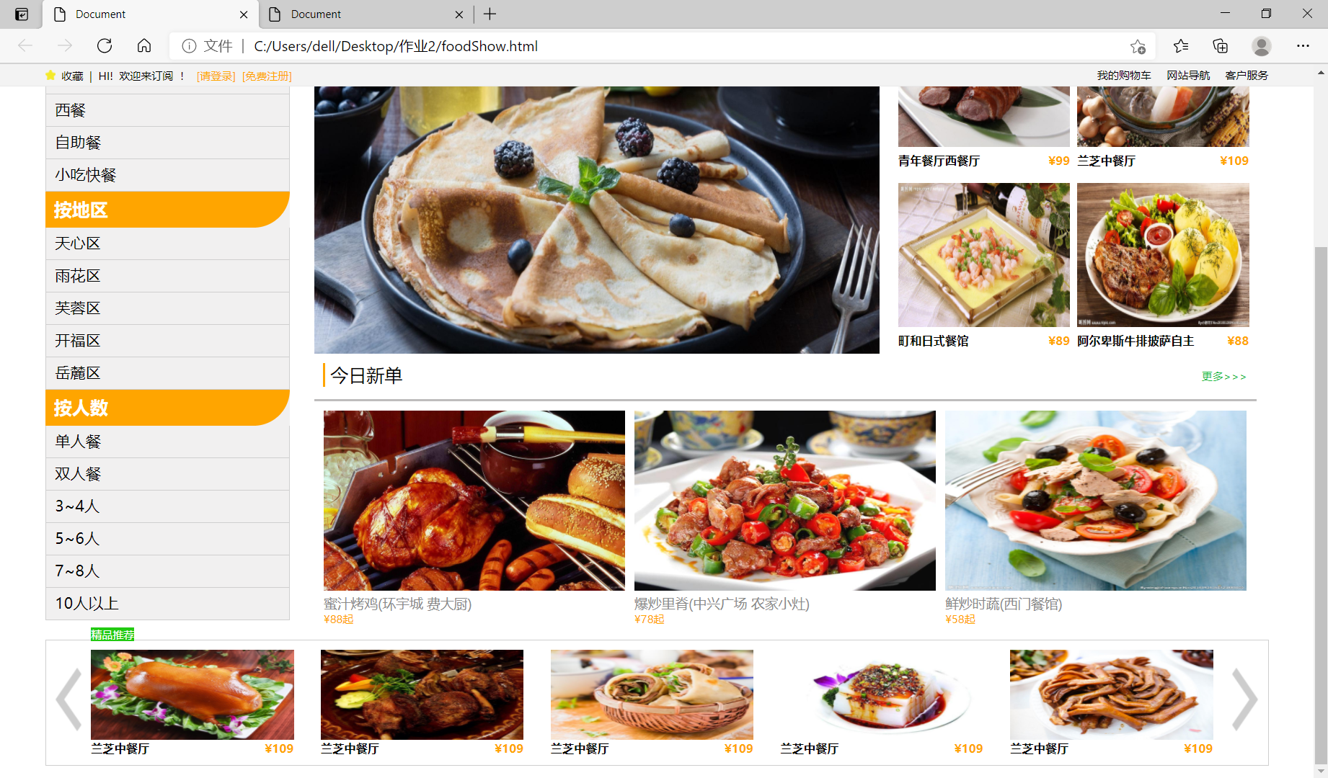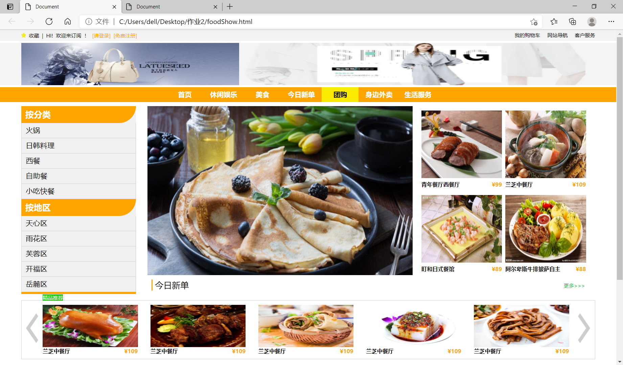

页面2：

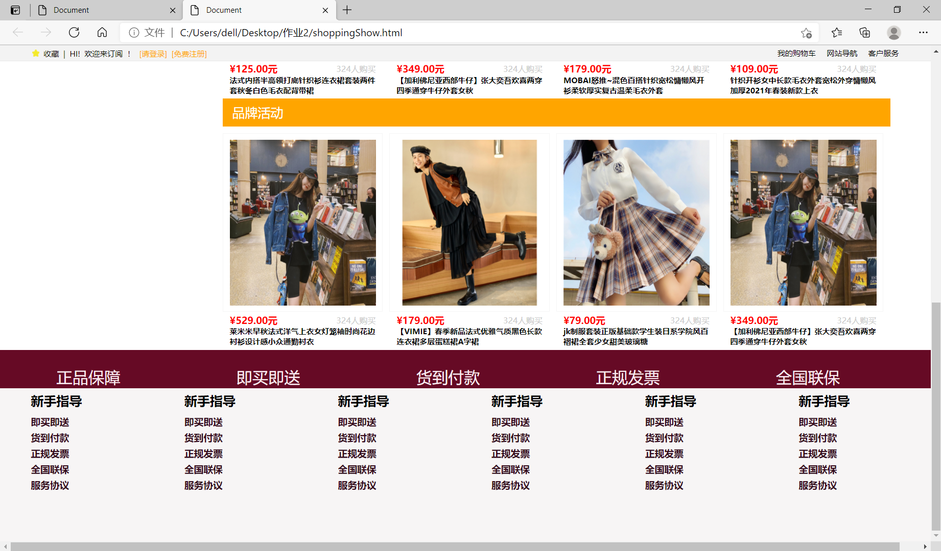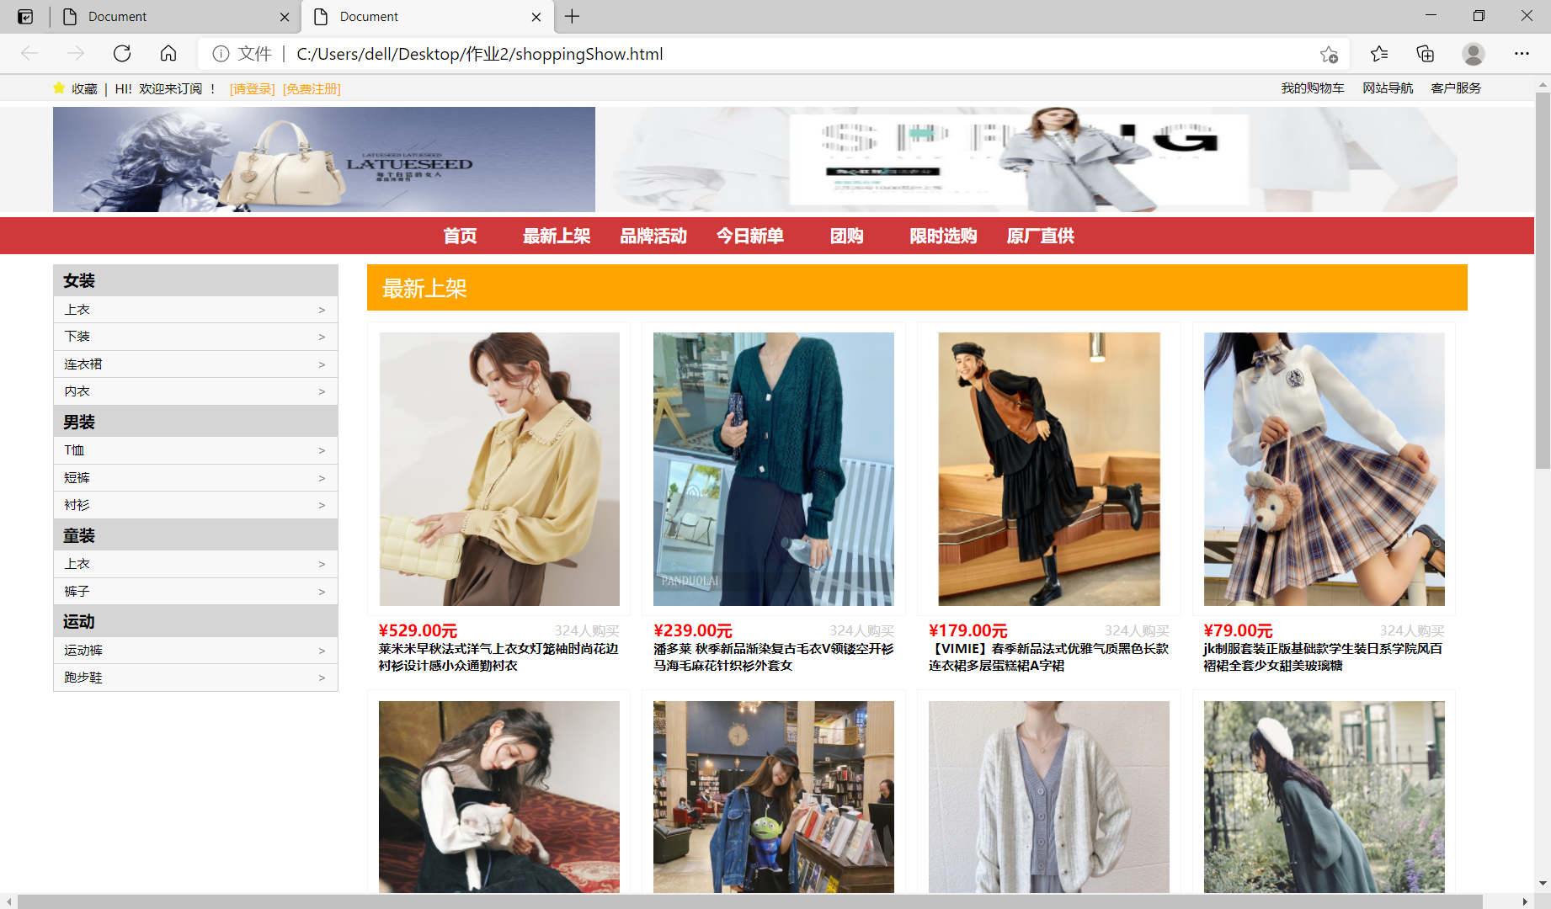

源代码：

页面1 html

<!DOCTYPE html>

<html lang="en">

<head>

    <meta charset="UTF-8">

    <meta http-equiv="X-UA-Compatible" content="IE=edge">

    <meta name="viewport" content="width=device-width, initial-scale=1.0">

    <title>Document</title>

    <link rel="stylesheet" type="text/css" href="orginal.css">

    <link rel="stylesheet" type="text/css" href="food.css">

</head>

<body>

    <!-- 包含全部 -->

    <div class="all">

        <!-- 固定顶部 -->

        <div class="topsetWrap">

            <div class="topSet w">

                <img src="./images/collct.png" class="topPic">

                <span>收藏</span> <span>|</span> <span>HI!</span> <span>欢迎来订阅</span> <span>！</span>

                <span class="topText">[请登录]</span> <span class="topText">[免费注册]</span>

                <span class="floatRight topRight">客户服务</span> <span class="floatRight topRight">网站导航</span>

                <span class="floatRight topRight">我的购物车</span>

            </div>

        </div>

        <!-- 顶部图片 -->

        <div class="topNav w">

            <img src="./images/top2.jfif" class="topone">

            <img src="./images/top3.jpg" class="toptwo">

        </div>

        <!-- 顶部导航栏 -->

        <div class="topLine">

            <ul class="clearfix">

                <li>首页</li>

                <li>休闲娱乐</li>

                <li>美食</li>

                <li>今日新单</li>

                <li>团购</li>

                <li>身边外卖</li>

                <li>生活服务</li>

            </ul>

        </div>

        <!-- 主要内容 -->

        <div class="container w">

            <div class="clearfix">

                <!-- 左边导航栏 -->

                <div class="leftBox floatLeft">

                    <ul class="leftMain">

                        <li>按分类</li>

                        <ul class="leftmini">

                            <li>火锅</li>

                            <li>日韩料理</li>

                            <li>西餐</li>

                            <li>自助餐</li>

                            <li>小吃快餐</li>

                        </ul>

                        <li>按地区</li>

                        <ul class="leftmini">

                            <li>天心区</li>

                            <li>雨花区</li>

                            <li>芙蓉区</li>

                            <li>开福区</li>

                            <li>岳麓区</li>

                        </ul>

                        <li>按人数</li>

                        <ul class="leftmini">

                            <li>单人餐</li>

                            <li>双人餐</li>

                            <li>3~4人</li>

                            <li>5~6人</li>

                            <li>7~8人</li>

                            <li>10人以上</li>

                        </ul>

                    </ul>

                </div>

                <!-- 右边内容主体盒子 -->

                <div class="rightBox floatLeft clearfix">

                    <!-- 右边上方图片推荐 -->

                    <div class="clearfix">

                        <div class="rightbig floatLeft">

                            <img src="./images/food1.jfif">

                        </div>

                        <div class="rightmin floatLeft">

                            <div class="minbox floatLeft">

                                <img src="./images/food2.jfif">

                                <div>青年餐厅西餐厅 <span>¥99</span></div>

                            </div>

                            <div class="minbox floatLeft">

                                <img src="./images/food4.jfif">

                                <div>兰芝中餐厅 <span>¥109</span></div>

                            </div>

                            <div class="minbox floatLeft">

                                <img src="./images/food6.jfif">

                                <div>町和日式餐馆 <span>¥89</span></div>

                            </div>

                            <div class="minbox floatLeft">

                                <img src="./images/food5.jfif">

                                <div>阿尔卑斯牛排披萨自主 <span>¥88</span></div>

                            </div>

                        </div>

                    </div>

                    <!-- 右边下方餐馆列表 -->

                    <div class="leftmain">

                        <div class="mianhead">

                            <div class="headline">今日新单 <span>更多>>></span></div>

                        </div>

                        <div class="clearfix">

                            <div class="mianbox floatLeft">

                                <img src="./images/food7.jfif">

                                <div class="title">蜜汁烤鸡(环宇城 费大厨)</div>

                                <div class="price">¥88起</div>

                            </div>

                            <div class="mianbox floatLeft">

                                <img src="./images/food3.jfif">

                                <div class="title">爆炒里脊(中兴广场 农家小灶)</div>

                                <div class="price">¥78起</div>

                            </div>

                            <div class="mianbox floatLeft">

                                <img src="./images/food8.jfif">

                                <div class="title">鲜炒时蔬(西门餐馆)</div>

                                <div class="price">¥58起</div>

                            </div>

                        </div>

                    </div>

                </div>

            </div>

        </div>

        <!-- 底部 -->

        <div class="footwrap">

            <div class="footer w">

                <div class="footermain clearfix">

                    <div class="footmini">精品推荐</div>

                    <img src="./images/left.png" class="iconleft">

                    <img src="./images/right.png" class="iconright">

                    <div class="footbox floatLeft">

                        <img src="./images/food9.jfif">

                        <div>兰芝中餐厅 <span>¥109</span></div>

                    </div>

                    <div class="footbox floatLeft pos">

                        <img src="./images/food10.jfif">

                        <div>兰芝中餐厅 <span>¥109</span></div>

                    </div>

                    <div class="footbox floatLeft pos">

                        <img src="./images/food11.jfif">

                        <div>兰芝中餐厅 <span>¥109</span></div>

                    </div>

                    <div class="footbox floatLeft pos">

                        <img src="./images/food12.jfif">

                        <div>兰芝中餐厅 <span>¥109</span></div>

                    </div>

                    <div class="footbox floatLeft pos">

                        <img src="./images/food13.jfif">

                        <div>兰芝中餐厅 <span>¥109</span></div>

                    </div>

                </div>

            </div>

        </div>

    </div>

</body>

</html>

页面2 html

<!DOCTYPE html>

<html lang="en">

<head>

    <meta charset="UTF-8">

    <meta http-equiv="X-UA-Compatible" content="IE=edge">

    <meta name="viewport" content="width=device-width, initial-scale=1.0">

    <title>Document</title>

    <link rel="stylesheet" type="text/css" href="orginal.css">

    <link rel="stylesheet" type="text/css" href="shop.css">

</head>

<body>

    <div class="all">

        <!-- 固定顶部 -->

        <div class="topsetWrap">

            <div class="topSet w">

                <img src="./images/collct.png" class="topPic">

                <span>收藏</span> <span>|</span> <span>HI!</span> <span>欢迎来订阅</span> <span>！</span>

                <span class="topText">[请登录]</span> <span class="topText">[免费注册]</span>

                <span class="floatRight topRight">客户服务</span> <span class="floatRight topRight">网站导航</span>

                <span class="floatRight topRight">我的购物车</span>

            </div>

        </div>

        <!-- 顶部图片 -->

        <div class="topNav w">

            <img src="./images/top2.jfif" class="topone">

            <img src="./images/top3.jpg" class="toptwo">

        </div>

        <!-- 顶部导航栏 -->

        <div class="topLine" style="background-color: rgb(207, 57, 57);">

            <ul class="clearfix">

                <li>首页</li>

                <li>最新上架</li>

                <li>品牌活动</li>

                <li>今日新单</li>

                <li>团购</li>

                <li>限时选购</li>

                <li>原厂直供</li>

            </ul>

        </div>

        <!-- 主要内容 -->

        <div class="container w">

            <div class="clearfix">

                <div class="leftBox floatLeft">

                    <ul class="leftMain">

                        <li>女装</li>

                        <ul class="leftmini">

                            <li>上衣</li>

                            <li>下装</li>

                            <li>连衣裙</li>

                            <li>内衣</li>

                        </ul>

                        <li>男装</li>

                        <ul class="leftmini">

                            <li>T恤</li>

                            <li>短裤</li>

                            <li>衬衫</li>

                        </ul>

                        <li>童装</li>

                        <ul class="leftmini">

                            <li>上衣</li>

                            <li>裤子</li>

                        </ul>

                        <li>运动</li>

                        <ul class="leftmini">

                            <li>运动裤</li>

                            <li>跑步鞋</li>

                        </ul>

                    </ul>

                </div>

                <div class="rightBox floatLeft">

                    <div class="rightbig">

                        <div class="mianhead clearfix">

                            <div class="headline">最新上架</div>

                        </div>

                        <div class="clearfix">

                            <div class="topbox floatLeft">

                                <div class="toppicbox">

                                    <img src="./images/cloth1.jpg">

                                    <div class="topprice">¥529.00元<span>324人购买</span></div>

                                    <div class="topdescription">莱米米早秋法式洋气上衣女灯笼袖时尚花边衬衫设计感小众通勤衬衣</div>

                                </div>

                            </div>

                            <div class="topbox internal floatLeft">

                                <div class="toppicbox">

                                    <img src="./images/cloth2.jpg">

                                    <div class="topprice">¥239.00元<span>324人购买</span></div>

                                    <div class="topdescription">潘多莱 秋季新品渐染复古毛衣V领镂空开衫马海毛麻花针织衫外套女</div>

                                </div>

                            </div>

                            <div class="topbox internal floatLeft">

                                <div class="toppicbox">

                                    <img src="./images/cloth3.jpg">

                                    <div class="topprice">¥179.00元<span>324人购买</span></div>

                                    <div class="topdescription">【VIMIE】春季新品法式优雅气质黑色长款连衣裙多层蛋糕裙A字裙</div>

                                </div>

                            </div>

                            <div class="topbox internal floatLeft">

                                <div class="toppicbox">

                                    <img src="./images/cloth4.jpg">

                                    <div class="topprice">¥79.00元<span>324人购买</span></div>

                                    <div class="topdescription">jk制服套装正版基础款学生装日系学院风百褶裙全套少女甜美玻璃糖</div>

                                </div>

                            </div>

                            <div class="topbox floatLeft">

                                <div class="toppicbox">

                                    <img src="./images/cloth5.jpg">

                                    <div class="topprice">¥125.00元<span>324人购买</span></div>

                                    <div class="topdescription">法式内搭半高领打底针织衫连衣裙套装两件套秋冬白色毛衣配背带裙</div>

                                </div>

                            </div>

                            <div class="topbox internal floatLeft">

                                <div class="toppicbox">

                                    <img src="./images/cloth6.jpg">

                                    <div class="topprice">¥349.00元<span>324人购买</span></div>

                                    <div class="topdescription">【加利佛尼亚西部牛仔】张大奕吾欢喜两穿四季通穿牛仔外套女秋</div>

                                </div>

                            </div>

                            <div class="topbox internal floatLeft">

                                <div class="toppicbox">

                                    <img src="./images/cloth7.jpg">

                                    <div class="topprice">¥179.00元<span>324人购买</span></div>

                                    <div class="topdescription">MOBAI怒推~混色百搭针织宽松慵懒风开衫柔软厚实复古温柔毛衣外套</div>

                                </div>

                            </div>

                            <div class="topbox internal floatLeft">

                                <div class="toppicbox">

                                    <img src="./images/cloth8.jpg">

                                    <div class="topprice">¥109.00元<span>324人购买</span></div>

                                    <div class="topdescription">针织开衫女中长款毛衣外套宽松外穿慵懒风加厚2021年春装新款上衣</div>

                                </div>

                            </div>

                        </div>

                        <div class="mianhead clearfix">

                            <div class="headline">品牌活动</div>

                        </div>

                        <div class="clearfix">

                            <div class="topbox floatLeft">

                                <div class="toppicbox">

                                    <img src="./images/cloth6.jpg">

                                    <div class="topprice">¥529.00元<span>324人购买</span></div>

                                    <div class="topdescription">莱米米早秋法式洋气上衣女灯笼袖时尚花边衬衫设计感小众通勤衬衣</div>

                                </div>

                            </div>

                            <div class="topbox internal floatLeft">

                                <div class="toppicbox">

                                    <img src="./images/cloth3.jpg">

                                    <div class="topprice">¥179.00元<span>324人购买</span></div>

                                    <div class="topdescription">【VIMIE】春季新品法式优雅气质黑色长款连衣裙多层蛋糕裙A字裙</div>

                                </div>

                            </div>

                            <div class="topbox internal floatLeft">

                                <div class="toppicbox">

                                    <img src="./images/cloth4.jpg">

                                    <div class="topprice">¥79.00元<span>324人购买</span></div>

                                    <div class="topdescription">jk制服套装正版基础款学生装日系学院风百褶裙全套少女甜美玻璃糖</div>

                                </div>

                            </div>

                            <div class="topbox internal floatLeft">

                                <div class="toppicbox">

                                    <img src="./images/cloth6.jpg">

                                    <div class="topprice">¥349.00元<span>324人购买</span></div>

                                    <div class="topdescription">【加利佛尼亚西部牛仔】张大奕吾欢喜两穿四季通穿牛仔外套女秋</div>

                                </div>

                            </div>

                        </div>

                    </div>

                </div>

            </div>

        </div>

        <div class="footer">

            <div class="footerLine">

                <ul class="clearfix">

                    <li>正品保障</li>

                    <li>即买即送</li>

                    <li>货到付款</li>

                    <li>正规发票</li>

                    <li>全国联保</li>

                </ul>

            </div>

            <div class="footcontent floatLeft">

                <ul class="footbox">

                    <div class="first">新手指导</div>

                    <li>即买即送</li>

                    <li>货到付款</li>

                    <li>正规发票</li>

                    <li>全国联保</li>

                    <li>服务协议</li>

                </ul>

            </div>

            <div class="footcontent floatLeft">

                <ul class="footbox">

                    <li class="first">新手指导</li>

                    <li>即买即送</li>

                    <li>货到付款</li>

                    <li>正规发票</li>

                    <li>全国联保</li>

                    <li>服务协议</li>

                </ul>

            </div>

            <div class="footcontent floatLeft">

                <ul class="footbox">

                    <li class="first">新手指导</li>

                    <li>即买即送</li>

                    <li>货到付款</li>

                    <li>正规发票</li>

                    <li>全国联保</li>

                    <li>服务协议</li>

                </ul>

            </div>

            <div class="footcontent floatLeft">

                <ul class="footbox">

                    <li class="first">新手指导</li>

                    <li>即买即送</li>

                    <li>货到付款</li>

                    <li>正规发票</li>

                    <li>全国联保</li>

                    <li>服务协议</li>

                </ul>

            </div>

            <div class="footcontent floatLeft">

                <ul class="footbox">

                    <li class="first">新手指导</li>

                    <li>即买即送</li>

                    <li>货到付款</li>

                    <li>正规发票</li>

                    <li>全国联保</li>

                    <li>服务协议</li>

                </ul>

            </div>

            <div class="footcontent floatLeft">

                <ul class="footbox">

                    <li class="first">新手指导</li>

                    <li>即买即送</li>

                    <li>货到付款</li>

                    <li>正规发票</li>

                    <li>全国联保</li>

                    <li>服务协议</li>

                </ul>

            </div>

        </div>

    </div>

</body>

</html>

公共样式表

/\* 公共样式定义 \*/

\* {

    margin: 0;

    padding: 0;

}

html {

    height: 100%;

}

li {

    list-style: none;

}

textarea {

    overflow: auto;

    resize: none;

}

a {

    text-decoration: none;

    outline: 0;

     color: #fff;

}

.clearfix:before,.clearfix:after {

    content: "";

    display: table;

}

.clearfix:after {

    clear: both;

}

.clearfix {

    \*zoom: 1;

}

.floatLeft{

    float: left;

}

.floatRight{

    float: right;

}

/\* body,html {

    background: #f6f6f6;

    font-family: "Hiragino Sans GB","Microsoft YaHei","微软雅黑",tahoma,arial,simsun,"宋体";

    font-size: 14px;

    width: 100%;

    line-height: 1.5;

} \*/

body,html {

 height: 100%;

 /\* overflow-x: hidden; \*/

}

.all {

    height: 100%;

    width: 100%;

    /\* background-color: #898989; \*/

}

/\* 顶部设置 \*/

.w {

    padding: 0 50px;

}

/\* 顶部细条 \*/

.topSet {

    height: 25px;

    width: 100%;

    background-color: #f3f3f3;

    padding: 1px 50px;

    box-sizing: border-box;

    border-bottom: 1px solid #e9e9e9;

    position: fixed;

    top: 0;

}

.topsetWrap{

    height: 25px;

}

.topPic {

    width: 11.5px;

    height: 11.5px;

}

.topSet span{

    line-height: 11.5px;

    font-size: 10px;

    margin-left: 2px;

}

.topText {

    color: orange;

}

.topRight {

    display: block;

    height: 11.5px;

    margin-top: 5px;

    padding-left: 15px;

    box-sizing: border-box;

}

/\* 顶部图片 \*/

.topNav {

    height: 100px;

    width: 100%;

    background-color: #f4f4f4;

    box-sizing: border-box;

    margin: 5px 0;

}

.topone {

    height: 100%;

    width: 38%;

}

.toptwo{

    height: 100%;

    width: 60%;

}

/\* 顶部导航栏 \*/

.topLine {

  height: 35px;

  width: 100%;

  background-color: orange;

  box-sizing: border-box;

  padding:0 27%;

}

.topLine li {

    height: 35px;

    width: 13%;

    color: #fff;

    display: inline-block;

    line-height: 35px;

    font-weight: 700;

    text-align: center;

}

.topLine li:hover {

    background-color: #fae900;

    color: #000;

}

/\* 内容设置 \*/

.container{

    margin-top: 10px;

    width: 100%;

    /\* height: 800px; \*/

    box-sizing: border-box;

    /\* background-color: rgb(219, 114, 202); \*/

}

.leftBox{

    width: 20%;

    height: auto;

    background-color: green;

    box-sizing: border-box;

    background-color: rgb(248, 248, 248);

}

.rightBox{

    width: 77%;

    /\* height: 500px; \*/

    /\* background-color: yellow; \*/

    margin-left: 2%;

    box-sizing: border-box;

}

页面一样式表

/\* 主体右边盒子 \*/

.leftMain>li {

    height: 40px;

    background-color: orange;

    font-size: 20px;

    line-height: 40px;

    color: #fff;

    font-weight: 700;

    padding: 0 10px;

    border-bottom-right-radius: 50px;

}

.leftmini>li{

    height: 35px;

    font-size: 17px;

    line-height: 35px;

    padding: 0 10px;

    border-bottom: 1px solid #cfcfcf;

    border-left: 1px solid #cfcfcf;

    border-right: 1px solid #cfcfcf;

}

/\* 主体左边盒子 \*/

.rightbig{

    width: 60%;

    height: 400px;

}

.rightbig img{

    height: 100%;

    width: 100%;

}

.rightmin{

    margin-left: 2%;

    width: 38%;

    height: 400px;

}

.minbox {

    margin-top: 10px;

    width: 48%;

    height: 190px;

    line-height: 20px;

    font-size: 13px;

    font-weight: 700;

    margin-right: 2%;

}

.minbox img {

    width: 100%;

    height: 160px;

}

.minbox span {

    float: right;

    color: orange;

}

/\* 主体下方盒子 \*/

.leftmain{

    width: 100%;

    /\* height: 300px; \*/

    /\* background-color: red; \*/

}

.mianhead {

    /\* box-sizing: border-box; \*/

    padding: 10px;

    height: 30px;

    border-bottom: 3px solid #bebdbd;

}

.headline {

    /\* box-sizing: border-box; \*/

    border-left: 3px solid orange;

    font-size: 20px;

    padding-left: 5px;

}

.mianhead span {

    float: right;

    font-size: 10px;

    line-height: 30px;

    color: #1cb93e;

}

.mianbox {

    box-sizing: border-box;

    margin-top: 10px;

    height: 240px;

    width: 32%;

    background-color: #fff;

    margin-left: 1%;

}

.mianbox img{

    height: 200px;

    width: 100%;

}

.title {

    font-size: 15px;

    color: #898989;

    line-height: 20px;

}

.price {

    font-size: 10px;

    color: orange;

    line-height: 15px;

}

/\* 底部 \*/

.footer {

    box-sizing: border-box;

    height: 170px;

    width: 100%;

    /\* background-color: pink; \*/

    padding-top: 15px;

    position: fixed;

    bottom: 0;

    background-color: #fff;

}

.footermain {

    box-sizing: border-box;

    width: 100%;

    height: 140px;

    border: 1px solid rgb(207, 207, 207);

    padding: 10px 50px;

    position: relative;

}

.footwrap{

    height: 170px;

}

.footbox {

    height: 120px;

    width: 225px;

    line-height: 15px;

    font-size: 13px;

    font-weight: 700;

}

.pos {

    margin-left: 30px;

}

.footbox img {

    width: 100%;

    height: 100px;

}

.footbox span {

    float: right;

    color: orange;

}

.iconleft {

    display: block;

    height: 70px;

    width: 50px;

    top: 30px;

    position: absolute;

    left: 0px;

}

.iconright {

    display: block;

    height: 70px;

    width: 50px;

    top: 30px;

    position: absolute;

    right: 0px;

}

.footmini {

    height: 15px;

    font-size: 10px;

    background-color: rgb(34, 202, 18);

    color: #fff;

    position: absolute;

    top: -15px;

    left: 50px;

}

页面2 样式表

/\* 主体右边盒子 \*/

.leftMain>li {

    height: 30px;

    background-color: rgb(214, 213, 213);

    font-size: 15px;

    line-height: 30px;

    color: #000;

    font-weight: 700;

    padding: 0 10px;

}

.leftmini>li{

    height: 25px;

    font-size: 12px;

    line-height: 25px;

    padding: 0 10px;

    border-bottom: 1px solid #cfcfcf;

    border-left: 1px solid #cfcfcf;

    border-right: 1px solid #cfcfcf;

}

.leftmini>li::after {

    content: ">";

    color: #898989 ;

    float: right;

}

/\* 主体左边盒子 \*/

.rightbig{

    width: 100%;

}

.mianhead {

    /\* box-sizing: border-box; \*/

    padding: 10px;

    height: 24px;

    background-color: orange;

}

.headline {

    /\* box-sizing: border-box; \*/

    line-height: 24px;

   color: #fff;

    font-size: 20px;

    padding-left: 5px;

}

.topbox {

    height: 340px;

    width: 24%;

    margin-top: 10px;

    box-sizing: border-box;

}

.toppicbox {

    width: 100%;

    height: 280px;

    padding: 10px;

    box-sizing: border-box;

    border: 1px solid rgb(245, 245, 245);

}

.toppicbox img{

  width: 100%;

  height: 260px;

}

.topprice {

    margin-top: 10px;

    height: 18px;

    line-height: 18px;

    font-size: 15px;

    color: red;

    font-weight: 700;

}

.topprice span {

    font-size: 13px;

    font-weight: normal;

    float: right;

    color: rgb(202, 202, 202);

}

.topdescription {

    height: 35px;

    font-size: 10px;

    font-weight: 700;

}

.internal {

    margin-left: 1%;

}

/\* 底部 \*/

.footer{

    width: 100%;

    height: 300px;

    background-color: rgb(247, 245, 245);

}

.footerLine {

  height: 60px;

  width: 100%;

  background-color: rgb(102, 10, 37);

  box-sizing: border-box;

}

.footerLine li {

    margin-top: 25px;

    height: 35px;

    font-size: 25px;

    width: 19%;

    color: rgb(250, 236, 240);

    display: inline-block;

    line-height: 35px;

    text-align: center;

}

.footcontent{

    height: 240px;

    width: 16.5%;

    /\* padding-left: 20%; \*/

}

.footbox {

    width: 100%;

    padding-left: 20%;

    font-size: 15px;

    line-height: 25px;

    font-weight: 700;

    color: rgb(51, 9, 25);

}

 .footcontent .first {

    font-size: 20px;

    line-height: 40px;

    color: #000;

}